|  |  |
| --- | --- |
| Date | 4 november 2022 |
| Team ID | PNT2022TMID00922 |
| Project Name | Signs with smart connectivity for better road safety |

**Use Dashboard Nodes For Creating UI(Web App)**

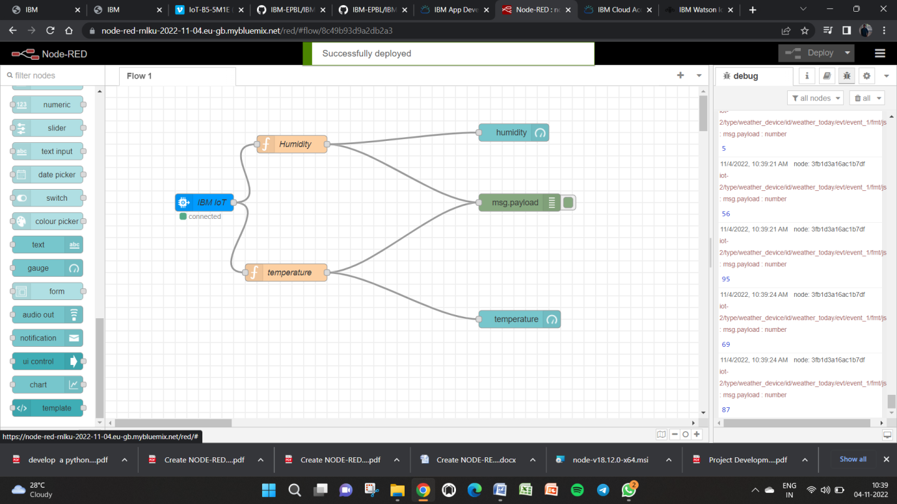

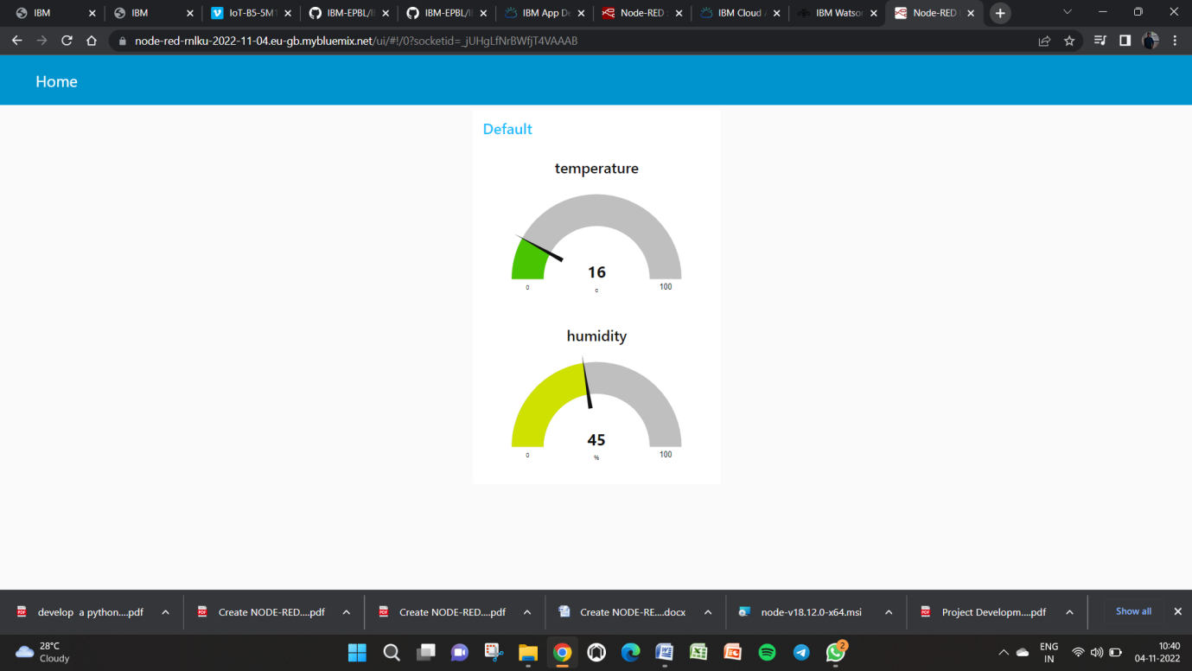

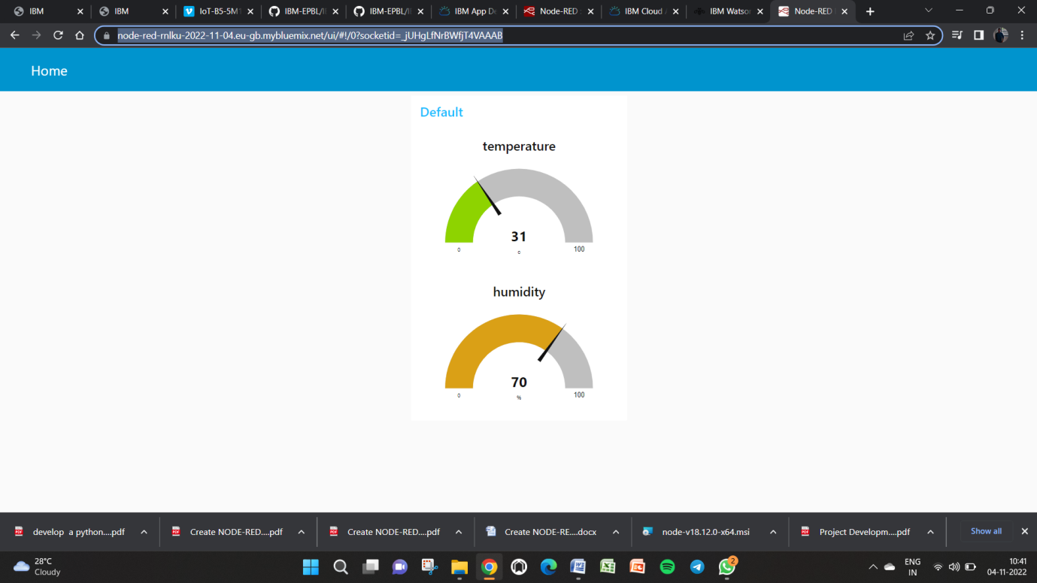

url for device:

<https://node-red-rnlku-2022-11-04.eu-gb.mybluemix.net/ui/#!/0?socketid=_jUHgLfNrBWfjT4VAAAB>